 

# AUTOMATIC SPRAYER MACHINE FOR AGRICULTURE

**A PROJECT REPORT**

**SHIBIVARSHAN S (927622BME083)**

**SHRIVARDHAN B (927622BME084)**

**SHYAM M (927622BME085)**

***in partial fulfillment for the award of the degree***

***of***

## BACHELOR OF ENGINEERING

**IN  
  
MECHANICAL ENGINEERING**

**M. KUMARASAMY COLLEGE OF ENGINEERING, KARUR**

## ANNAUNIVERSITY: CHENNAI 600025

**NOVEMBER 2023**

 

# AUTOMATIC SPRAYER MACHINE FOR AGRICULTURE

**A MINOR PROJECT REPORT**

***Submitted by***

**SHIBIVARSHAN S (927622BME083)**

**SHRIVARDHAN B (927622BME084)**

**SHYAM M (927622BME085)**

***in partial fulfillment for the award of the degree of***

**BACHELOR OF ENGINEERING**

***in***

## MECHANICAL ENGINEERING

**M. KUMARASAMY COLLEGE OF ENGINEERING, KARUR**

## ANNA UNIVERSITY: CHENNAI 600025

**NOVEMBER 2023**

# M. KUMARASAMY COLLEGE OF ENGINEERING, KARUR

## BONAFIDE CERTIFICATE

Certified that this project report “**AUTOMATIC SPRAYER MACHINE FOR AGRICUTURE”** is the bonafide work of **“SHIBIVARSHAN S (927622BME083), SHRIVARDHAN B (927622BME084), and SHYAM M (927622BME085)”** who carried out the project work during the academic year 2023 – 2024 under my supervision. Certified further, that to the best of my knowledge the work reported here in does not form part of any other project report or dissertation on the basis of which a degree or award was conferred on an earlier occasion on this or any other candidate.

|  |  |
| --- | --- |
| **SIGNATURE** | **SIGNATURE** |
| Dr. M. MOHAN PRASAD M.E., M.B.A., Ph.D., | Dr. L. EMMANUAL M.E., Ph.D., |
| **HEAD OF THE DEPARTMENT,** | **SUPERVISOR**  **ASSISANT PROFESSOR** |
| Department of Mechanical Engineering, | Department of Mechanical Engineering, |
| M. Kumarasamy College of Engineering, | M. Kumarasamy College of Engineering, |
| Thalavapalayam, Karur - 639113. | Thalavapalayam, Karur - 639113. |

This project report has been submitted for the end semester project viva voce Examination held on ________________

INTERNAL EXAMINER EXTERNAL EXAMINER

ii

DECLARATION

We affirm that the Project titled **“AUTOMATIC SPRAYER MACHINE FOR AGRICULTURE”** being submitted in partial fulfillment off or the End Semester Examination of **B.E. MECHANICAL ENGINEERING**, is the original work carried out by us. It has not formed the part of any other project or dissertation on the basis of which a degree or award was conferred on an earlier occasion on this or any other candidate.

Student Name Signature

1. SIBIVARSHAN S ---------------------------
2. SHYAM M ---------------------------
3. SHRIVARDHAN B ---------------------------

Name and signature of the supervisor with date

Dr. L. EMMANUAL

iii

**ACKNOWLEDGEMENT**

Our sincere thanks to Dr. K. Ramakrishnan, B.E, Secretary, M.Kumarasamy College of Engineering for providing extraordinary infrastructure, which help edusto complete the project in time.

It is a great privilege for us to express our gratitude to our Principal Dr. B.S. Murugan M.Tech, Ph.D., for providing us right ambiance for carrying out the project work.

We would like to thank Dr. M. Mohan Prasad M.E, M.B.A., Ph.D, Head, Department of Mechanical Engineering, for his unwavering moral support throughout the evolution of the project.

We offer our whole hearted thanks to our internal guide Dr.L.Emmanual M.E., Ph.D., Assistant Professor, Department of Mechanical Engineering, for his constant encouragement, kind co-operation, valuable suggestions and support rendered in making our project a success.

We offer our whole hearted thanks to our project coordinator Dr. M.Loganathan M.E., Ph.D., Professor, Department of Mechanical Engineering, for his constant encouragement, kind co-operation, valuable suggestions and support rendered in making our project a success.

We glad to thank all the Teaching and Non-Teaching Faculty Members of Department of Mechanical Engineering for extending a warm helping hand and valuable suggestions throughout the project.

Words are boundless to thank Our Parents and Friends for their constant encouragement to complete this project successfully.

iv

**INSTITUTIONVISION&MISSION**

**Vision**

* To emerge as a leader among the top institutions in the field of technical education.

**Mission**

* Produce smart technocrats with empirical knowledge who can surmount the global challenges.
* Create a diverse, fully-engaged, learner-centric campus environment to provide quality education to the students.
* Maintain mutually beneficial partnerships with our alumni, industry and professional associations.

**DEPARTMENT VISION, MISSION, PEO, PO & PSO**

**Vision**

* To create globally recognized competent Mechanical engineers to work in multi-cultural environment.

**Mission**

* To impart quality education in the field of mechanical engineering and to enhance their skills, to pursue careers or enter into higher education in their area-of-interest.
* To establish a learner-centric atmosphere along with state-of-the-art research facility.
* To make collaboration with industries, distinguished research institution and to become a center of excellence

**PROGRAM EDUCATIONAL OBJECTIVES(PEOS)**

The graduates of Mechanical Engineering will be able to

* PEO1: Graduates of the program will accommodate insightful information of engineering principles necessary for the applications of engineering.
* PEO2: Graduates of the program will acquire knowledge of recent trends in technology and solve problem in industry.
* PEO3: Graduates of the program will have practical experience and interpersonal skills to work both in local and international environments.
* PEO4: Graduates of the program will possess creative professionalism, understand their ethical responsibility and committed towards society.

v

**PROGRAM OUTCOMES**

**The following are the Program Outcomes of Engineering Graduates will be able to:**

1. **Engineering knowledge:** Apply the knowledge of mathematics, science, engineering fundamentals, and an engineering specialization to the solution of complex engineering problems.
2. **Problem analysis:** Identify, formulate, review research literature, and analyze complex engineering problems reaching substantiated conclusions using first principles of mathematics, natural sciences, and engineering sciences.
3. **Design / Development of solutions:** Design solutions for complex engineering problems and design system components or processes that meet the specified needs with appropriate consideration for the public health and safety, and the cultural, societal, and environmental considerations.
4. **Conduct investigations of complex problems:** Use research-based knowledge and research methods including design of experiments, analysis and interpretation of data, and synthesis of the information to provide valid conclusions.
5. **Modern tool usage:** Create, select, and apply appropriate techniques, resources, and modern engineering and IT tools including prediction and modeling to complex engineering activities with an understanding of the limitations.
6. **The engineer and society:** Apply reasoning informed by the contextual knowledge to assess societal, health, safety, legal and cultural issues and the consequent responsibilities relevant to the professional engineering practice.
7. **Environment and sustainability:** Understand the impact of the professional engineering solutions in societal and environmental contexts, and demonstrate the knowledge of, and need for sustainable development.
8. **Ethics:** Apply ethical principles and commit to professional ethics and responsibilities and norms of the engineering practice.
9. **Individual and team work:** Function effectively as an individual, and as a member or leader in diverse teams, and in multidisciplinary settings.
10. **Communication:** Communicate effectively on complex engineering activities with the engineering community and with society at large, such as, being able to comprehend and write effective reports and design documentation, make effective presentations, and give and receive clear instructions.
11. **Project management and finance:** Demonstrate knowledge and understanding of the engineering and management principles and apply these to one’s own work, as a member and leader in a team, to manage projects and in multidisciplinary environments.
12. **Life - long learning:** Recognize the need for, and have the preparation and ability to engage in independent and life -long learning in the broadest context of technological change.

vi

**PROGRAM SPECIFIC OUTCOMES (PSOs)**

**The following are the Program Specific Outcomes of Engineering Graduates:**

The students will demonstrate the abilities

1. **Real world application:** To comprehend, analyze, design and develop innovative products and provide solutions for the real-life problems.
2. **Multi-disciplinary areas:** To work collaboratively on multi-disciplinary areas and make quality projects.
3. **Research oriented innovative ideas and methods:** To adopt modern tools, mathematical, scientific and engineering fundamentals required to solve industrial and societal problems.

|  |  |  |
| --- | --- | --- |
| **Course Outcomes** | At the end of this course, learners will be able to: | **Knowledge Level** |
| CO - 1 | Identify the issues and challenges related to industry, society and environment. | Apply |
| CO - 2 | Describe the identified problem and formulate the possible solutions. | Apply |
| CO -3 | Design / Fabricate new experimental set up/devices to provide solutions for the identified problems | Analyse |
| CO -4 | Prepare a detailed report describing the project outcome | Apply |
| CO - 5 | Communicate outcome of the project and defend by making an effective oral presentation. | Apply |

**MAPPING OF PO & PSO WITH THE PROJECT OUTCOME**

|  |  |  |  |  |  |  |  |  |  |  |  |  |  |  |  |
| --- | --- | --- | --- | --- | --- | --- | --- | --- | --- | --- | --- | --- | --- | --- | --- |
| **Course Outcomes** | **Program Outcomes** | | | | | | | | | | | | **Program Specific Outcomes** | | |
| 1 | 2 | 3 | 4 | 5 | 6 | 7 | 8 | 9 | 10 | 11 | 12 | 1 | 2 | 3 |
| CO - 1 | 3 | 3 | 3 | 3 | 2 | 2 | 2 | 2 | 3 | 3 | 2 | 2 | 3 | 2 | 3 |
| CO - 2 | 3 | 3 | 3 | 3 | 2 | 2 | 2 | 2 | 3 | 3 | 2 | 2 | 3 | 2 | 3 |
| CO - 3 | 3 | 3 | 3 | 3 | 2 | 2 | 2 | 2 | 3 | 3 | 2 | 2 | 3 | 2 | 3 |
| CO - 4 | 3 | 3 | 3 | 3 | 2 | 2 | 2 | 2 | 3 | 3 | 2 | 2 | 3 | 2 | 3 |
| CO - 5 | 3 | 3 | 3 | 3 | 2 | 2 | 2 | 2 | 3 | 3 | 2 | 2 | 3 | 2 | 3 |

vi

**CONTENTS**

|  |  |  |  |  |
| --- | --- | --- | --- | --- |
| **Chapter** | **Title** | | | **Page no:** |
| **1** | **ABSTRACT AND INTRODUCTION** | | | **2** |
| **2** | **2.1** | | **WATER SPRAYER** | **4** |
| **2.2** | | **SPRAYER DIFFERENCE** | **5** |
| **2.3** | | **TYPES OF HYDRALIC SPRAYER** | **5** |
| **3** | **CONSTRUCTION AND WORKING PRINCIPLE** | | | **8** |
| **4** | **MAJOR COMPONENTS** | | | **9** |
| **5** | **ADVANTAGES AND APLLICATIONS** | | | **18** |
| **6** | **6.1** | **MATERIAL USED** | | **19** |
| **6.2** | **COST ESTIMATION** | | **20** |
| **7** | **2D LAYOUT** | | | **21** |
| **8** | **CONCLUSION** | | | **22** |
|  | **REFERENCES** | | | **23** |

**CHAPTER 1**

**ABSTRACT AND INTRODUCTION**

**1.1 ABSTRACT**

The project is intended to help the farmers as India being an Agriculture based country. It is a water Sprayer mounted on a movable frame which is operated mechanically without any external source of energy. The aim of developing such a concept is primarily because of preventing the three major drawbacks of the pump being used currently- Firstly, the farmer has to carry the entire weight of the spraying pump on his shoulder; secondly, he has to continuously use his one hand to pump using the handle; thirdly, the farmers don’t take enough precaution while handling chemicals which results in fatal diseases because of its direct contact. All these factors have been taken care of in this project along with being cost effective, light in weight and good in strength. The pump already available with the farmer can be directly used in this mechanism. The handle of the sprayer will be mechanically operated through the rotating crank. This will result into the reciprocating motion of the piston and hence pumping will be done in user friendly manner.

**1.2 INTRODUCTION**

India is a land of agriculture which comprises of small, marginal and rich farmers. Small scale farmers are interested in manually lever operated knapsack sprayer because of its versatility, cost and design. As the pests and insects nowadays have been growing up in abundance throughout the vegetation and also having developed their immunity towards the surrounding environment, it becomes compulsory for the farmers across the globe to spray pesticides and insecticides frequently in order to protect their crops from getting rotten and consumed by insects. Protection from parasites is an important factor in all the agricultural operations, and calls for continual monitoring and prompt action when needed. In many cases, different equipment, pesticides and manpower are required for this purpose which accounts for the majority of production expenses. This would ultimately affect the economy of the farmer, hence it needs serious consideration.

**CHAPTER 2**

**2.1 WATER SPRAYERS**

The most important goal in the application of agricultural pesticides is to get uniform distribution of the chemicals throughout the crop foliage. Under dosing may not give the desired coverage and control needed. Overdosing is expensive as it wastes pesticide and increases the potential for groundwater contamination.

Two general types of sprayers are available for greenhouse application of pesticides: hydraulic and low-volume. There are many variations of these that fit particular crops or growing methods.

In the hydraulic sprayer, a pump supplies energy that carries spray material to the target (plant foliage). Water is the carrier and the pump creates the pressure at 40-1000 psi. Spray material is usually applied to "wet" or "drip." Nozzles on the boom or handheld gun break the spray into small droplets and direct it to the foliage.

In a low-volume (LV) sprayer, spray material in a water or oil carrier is injected into a high-speed air stream developed by a fan, blower or compressor. In most LV sprayers, a small pump is used to inject a concentrate pesticide solution into the air stream. The speed of the air stream may be as high as 200 mph. To get sufficient coverage, the air within the foliage canopy must be replaced with air that contains the pesticide. As the droplet size is much smaller, good coverage can be achieved with less chemical.

**2.2 SPRAYER DIFFERENCES**

One way to distinguish between a hydraulic sprayer and low-volume sprayer is by droplet size. Hydraulic sprayers produce a spray with most droplets in the 200-400 micron diameter range (thickness of the human hair is about 100 microns). Low-volume sprayers develop a mist (50-100 microns) or fog (0.05-50 microns). Small droplets from a mist or fog applicator can result in more uniform coverage and greater likelihood of contact with the insect or disease. In contrast to the hydraulic sprayer, spray material is usually applied to "glisten" as it is difficult to see the individual droplets on the leaf.

One disadvantage to smaller droplets is that they evaporate quicker when the humidity is low and may not reach the target. Another is that the tiny droplets tend to bounce or skip on the leaf surface. This can be overcome somewhat by adding a spreader and sticker.

**2.3 TYPES OF HYDRAULIC SPRAYERS**

A hydraulic sprayer contains the following components: tank, pump with agitator, pressure gauge, regulating valve, relief valve, control valves, piping and nozzles, power source and support frame.

**2.3.1 COMPRESSED AIR SPRAYER**

The smallest sprayers are hand-carried, compressed air sprayers. They contain a 1- to 5-gallon tank with an air pump in the top and a wand with a nozzle for directing the spray. Their best use is for spot treatment of small areas. In operation, the tank has to be pumped up frequently to maintain pressure, and the tank must be shaken to agitate the chemical.

**2.3.2 BACKPACK SPRAYER**

The tank in this sprayer holds about four gallons of material. A hand-operated pump pressurizes the spray material as the operator walks along, and the wand with nozzle directs the spray to the target.  Its use is limited to small areas that can be reached from a walkway**.**

**2.3.3 SKID-MOUNTED SPRAYER**

With a tank size up to 200 gallons, these sprayers will fit onto an ATV or electric cart. They can also be mounted on wheels and pulled by hand or with a compact tractor. A small electric or gas engine powers the pump. The unit may contain a hose reel and gun or a boom with nozzles.

**2.3.4 BACKPACK MIST BLOWER**

A small gas engine and integral fan creates an air stream with a velocity of 100-200 mph. Concentrate spray injected into the air stream by a special nozzle is carried to the foliage by the air. The spraying technique is more complicated than with a hydraulic sprayer. The nozzle should be directed into the plant canopy to get good penetration and coverage, but it should be kept at least six feet away from the plants to avoid blast damage. The operator should visualize that all the air within the canopy must be replaced by the air from the mist blower.

**2.3.5 ELECTROSTATIC SPRAYER**

Compressed air, given a negative electric charge as it travels through the nozzle, forms spray droplets and carries them to the plants. This helps to create more uniformly sized particles that disperse well because they repel each other. Charged particles are attracted to leaves, metal and some plastics; when they strike a surface, these particles create a momentary overcharge that repels other particles. These other particles land elsewhere on the leaf, so there is more uniform coverage.

The simplest electrostatic sprayer is backpack-carried and contains a tank and spray gun. It requires an independent air supply to charge the tank. Other units are cart-mounted with an integral compressor powered by a gas engine or electric motor. Electrostatic sprayers work best if the spray distance is less than 15.

**CHAPTER 3**

**CONSTRUCTION AND WORKING PRINCIPLES**

**3.1 CONSTRUCTION**

The base frame which acts a chassis is fabricated with the help of square tubes and channels by metal cutting and metal joining process called welding. A wheel is attached to the chassis for its displacement at the front end portion of frame. A hand lever operated sprayer can is mounted on the rear end portion of chassis. The crank wheel is mounted with the main wheel shaft which get coupled with sprocket wheel which is fixed at the mid portion of chassis with bearing supported end. A chain drive is used to connect this crank wheel and sprocket, this sprocket has an eccentric pin on its surface which is linked with hand lever of pump with the help of coupler link. The outlet of sprayer is attached with four nozzles which is placed at the front end portion of chassis. The hand lever is provided at the rear end portion which helps user to handle the equipment.

**3.2 WORKING PRINCIPLE**

Initially water or fertilizer which has to be sprayed is loaded inside the sprayer can and the setup is placed on the field where the spraying operation to be conducted. A manual effort is applied on the chassis which allows the wheel mounted with it to rotate about its axis, this rotation allows the crank wheel attached with it to rotate. This rotation tends to rotate sprocket gear and this makes hand lever of pump to activate linearly. This activation pressurizes the fluid stored inside tank and makes it to exhaust through outlet. This pressurized fluid from outlet is transferred to the nozzles from there the fluid is sprayed on the field

**CHAPTER 4**

**MAJOR COMPONENTS**

**MAJOR COMPONENS**

1. CHAIN DRIVE
2. WHEEL
3. DISC
4. NOZZLE
5. FRAME
6. BEARING
7. METAL STRIP
8. SHAFT
9. AGRICULTURAL SPRAYER

**SPROCKET**

**Chain drive** is a way of transmitting mechanical power from one place to another. It is often used to convey power to the wheels of a vehicle, particularly bicycles and motorcycles. It is also used in a wide variety of machines besides vehicles.

• Low bending stiffness

• High efficiency

• Relatively cheap

**SPECIFICATION OF AXLE:**

|  |  |
| --- | --- |
| Material | **Mild Steel** |
| Shape | Cylindrical rod |
| Length | 50mm |
| Diameter | 13mm |
| Inner diameter of supporting axle | 15 mm |
| Outer diameter of supporting axle | 17mm |
| Length | 30mm |
| Thickness | 3mm |

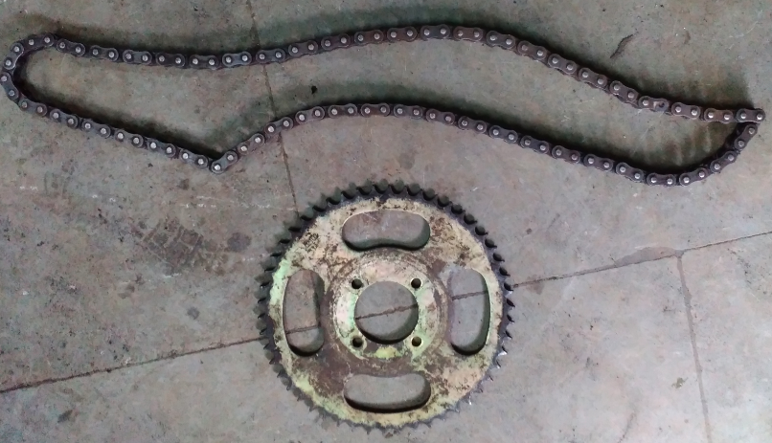

**CHAIN SPROCKET**

|  |  |
| --- | --- |
| Material | High Carbon Steel |
| Pitch | 12.7mm |
| Width | 30mm |
| Teeth | 16 |
| Balls | High carbon high chromium steel balls |

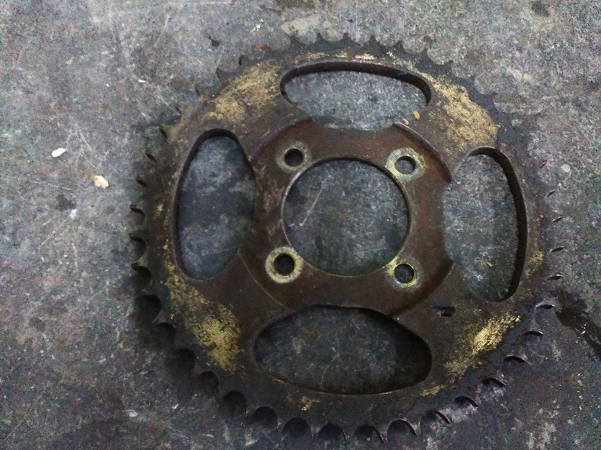

SPRAYER

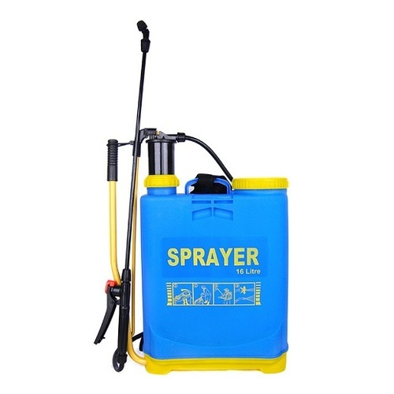

A sprayer is a [device](https://en.wikipedia.org/wiki/Tool) used to [spray](https://en.wikipedia.org/wiki/Spray_(liquid_drop)) a [liquid](https://en.wikipedia.org/wiki/Liquid).

In [agriculture](https://en.wikipedia.org/wiki/Agriculture), a sprayer is a piece of [equipment](https://en.wikipedia.org/wiki/Agricultural_equipment) that is used to apply [herbicides](https://en.wikipedia.org/wiki/Herbicides), [pesticides](https://en.wikipedia.org/wiki/Pesticides), and [fertilizers](https://en.wikipedia.org/wiki/Fertilizers) on agricultural crops. Sprayers range in size from man-portable units (typically [backpacks](https://en.wikipedia.org/wiki/Backpack) with [spray guns](https://en.wikipedia.org/wiki/Spray_gun)) to trailed sprayers that are connected to a tractor, to self-propelled units similar to [tractors](https://en.wikipedia.org/wiki/Tractor), with [boom mounts](https://en.wikipedia.org/wiki/Crane_(machine)) of 60–151 feet in length.

**WHEEL**

A tire (American English) or tire (British English) is a ring-shaped vehicle component that covers the [wheel’s](https://en.wikipedia.org/wiki/Rim_(wheel)) rim to protect it and enable better vehicle performance. Most tires, such as those for automobiles and bicycles, provide traction between the vehicle and the road while providing a flexible cushion that absorbs shock.

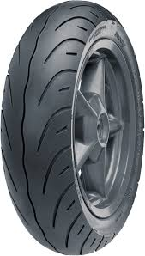

**DISK**

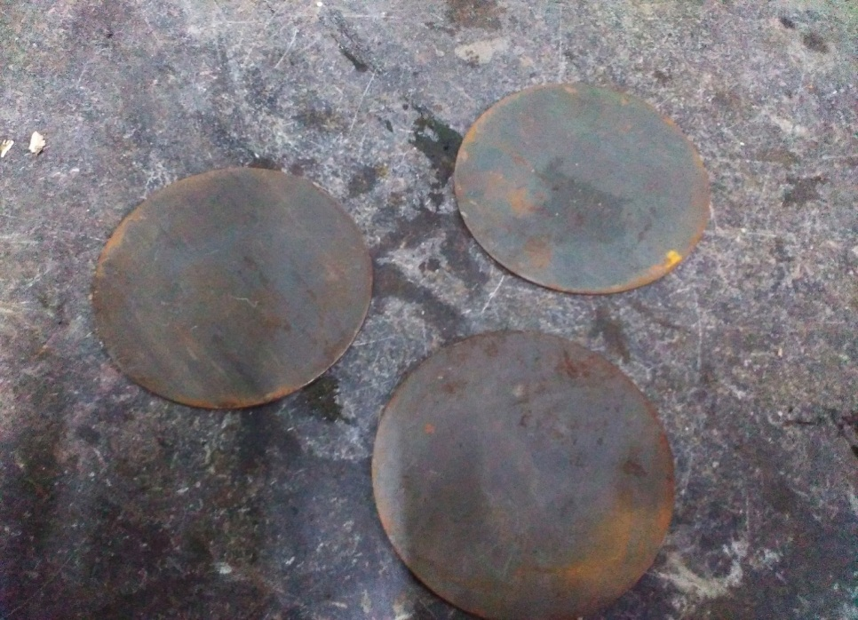

**Material: Mild steel**

**Outer diameter: 250mm**

**Thickness: 5mm**

In geometry, a **disk** is the region in a plane bounded by a circle. A disk is said to be closed if it contains the circle that constitutes its boundary.

The disk has circular symmetry.

**NOZZLE**

A nozzle is a device designed to control the direction or characteristics of a [fluid](https://en.wikipedia.org/wiki/Fluid) flow (especially to increase velocity) as it exits (or enters) an enclosed chamber or [pipe](https://en.wikipedia.org/wiki/Pipe_(material)).

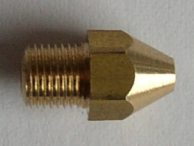

A nozzle is often a pipe or tube of varying cross sectional area, and it can be used to direct or modify the flow of a fluid ([liquid](https://en.wikipedia.org/wiki/Liquid) or [gas](https://en.wikipedia.org/wiki/Gas)). Nozzles are frequently used to control the rate of flow, speed, direction, mass, shape, and/or the pressure of the stream that emerges from them. In a nozzle, the velocity of fluid increases at the expense of its pressure energy.

**SPECIFICATION**

Material: Steel

Diameter:0-0.5mm 0.5-1mm

Pressure:1-3 bar to 3-6 bar

**SHAFT**

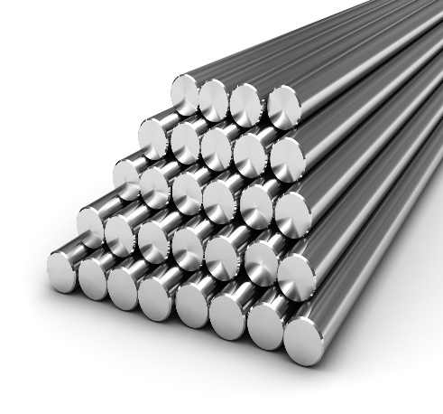

**Specifications**

Shaft diameter: 12mm

Material: mild steel

Length:26 inch

**Shaft**

Shaft is a common and important machine element. It is a rotating member, in general, has a circular cross-section and is used to transmit power. The shaft may be hollow or solid. The shaft is supported on bearings and it rotates a set of gears or pulleys for the purpose of power transmission. The shaft is generally acted upon by bending moment, torsion and axial force

**BALL BEARING**

A ball bearing is a type of [rolling-element bearing](https://en.wikipedia.org/wiki/Rolling-element_bearing) that uses [balls](https://en.wikipedia.org/wiki/Ball_(bearing)) to maintain the separation between the [bearing](https://en.wikipedia.org/wiki/Bearing_(mechanical)) [races](https://en.wikipedia.org/wiki/Race_(bearing)).

The purpose of a ball bearing is to reduce rotational friction and support [radial](https://en.wikipedia.org/wiki/Radius) and [axial](https://en.wikipedia.org/wiki/Axis_of_rotation) loads. It achieves this by using at least three races to contain the balls and transmit the loads through the balls. In most applications, one race is stationary and the other is attached to the rotating assembly (e.g., a hub or shaft). As one of the bearing races rotates it causes the balls to rotate as well. Because the balls are rolling they have a much lower [coefficient of friction](https://en.wikipedia.org/wiki/Coefficient_of_friction) than if two flat surfaces were sliding against each other.

[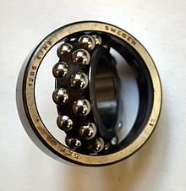](https://en.wikipedia.org/wiki/File:Wingquist_bearing00.jpg)

**METAL FRAME**

The metal frame is generally made of **mild steel** bars for machining, suitable for lightly stressed components including studs, bolts, gears and shafts. It can be case-hardened to improve wear resistance. They are available in bright rounds, squares and flats, and hot rolled rounds

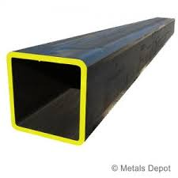

Suitable machining allowances should therefore be added when ordering. It does not contain any additions for enhancing mechanical or machining properties. Bright drawn mild steel is an improved quality material, free of scale, and has been cold worked (drawn or rolled) to size. It is produced to close dimensional tolerances. Straightness and flatness are better than black steel. It is more suitable for repetition precision machining. Bright drawn steel has more consistent hardness, and increased tensile strength. Bright steel can also be obtained in precision turned or ground form if desired.

**CHAPTER 5**

**ADVANTAGES AND APPLICATIONS**

**ADVANTAGES**

* Less Initial and Maintenance cost
* Does not require any External Source of Energy
* Safe for Operation
* No Fatigue to Operator
* Does not require to buy any Specially Designed Pump (conventional backpack pump can be directly used here)
* Can work efficiently during all Seasons
* Uniform Spraying
* Portable & Ergonomic
* No Running cost

**APPLICATION**

* This setup can be used for small and medium fields and by increasing the number of nozzles and specification of pump this setup can also be used for large fields also.

**CHAPTER 6**

**6.1 MATERIAL USED**

|  |  |  |  |
| --- | --- | --- | --- |
| **S.No** | **DESCIRPTION** | **QTY** | **MATERIAL** |
| 1 | CHAIN DRIVE | 1 | STAINLESS STEEL |
| 2 | NOZZLE | 1 | STAINLESS STEEL |
| 3 | BEARING | 4 | STAINLESS STEEL |
| 4 | FRAME | AS PER REWUIRMENT | MILD STEEL |
| 5 | SHAFT | AS PER REWUIRMENT | MILD STEEL |
| 6 | METAL STRIP | AS PER REWUIRMENT | MILD STEEL |
| 7 | AGRICULTURAL SPRAYER | 1 | PLASTIC |
| 8 | WHEEL | 1 | RUBBER |
| 9 | DISC | 1 | MILD STEEL |

**6.2 COST ESTIMATION**

|  |  |  |
| --- | --- | --- |
| **SL.NO** | **DISCRIPTION** | **COST Rs:** |
| 1 | CHAIN DRIVE | 1500 |
| 2 | NOZZLE | 400 |
| 3 | BEARING | 400 |
| 4 | FRAME | 1200 |
| 5 | SHAFT | 400 |
| 6 | METAL STRIP | 300 |
| 7 | AGRICULTURAL SPRAYER | 800 |
| 8 | WHEEL | 800 |
| 9 | DISC | 800 |
| 10 | TOTAL | 6800 |

**CHAPTER 7**

**2D LAYOUTS OF MODEL AND CONCLUSION**

**2D LAYOUT:**

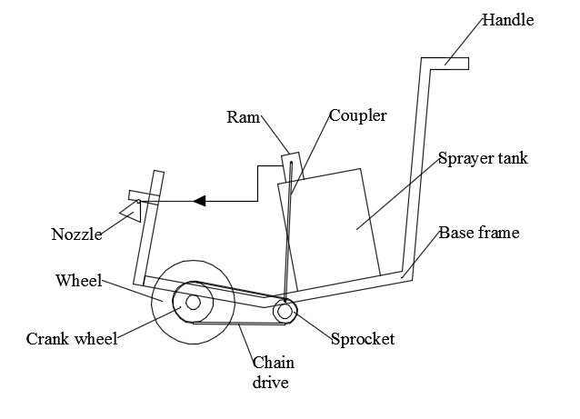

**CHAPTER 8**

**CONCLUSION**

**CONCLUSION**

Sprayers are commonly used on farms to spray pesticides, herbicides, fungicides, and defoliants as a means of crop quality control. To produce more output from the farm mechanization in the industrial sector is needed. It gives more productivity in less input. By mechanization we can reduces the efforts of labors and uniformly spray the fertilizers and pesticides all over the farm. So there is a need if mechanization in industrial areas in India

**REFERENCES**

1. R. Joshua, V. Vasu and P. Vincent. (2010) “Solar Sprayer - An Agriculture Implement”, “International Journal of Sustainable Agriculture 2 (1): pp. 16-19, ISSN 2079-2107”
2. M. A. Miller, B. L. Steward, M. L. Westphalen “Effects of multi−mode four−wheel steering on sprayer machine performance”, American Society of Agricultural Engineers ISSN 0001−2351
3. R. D. Fox, R. C. Derksen. (2003) “Visual and image system measurement of spray deposits using water–sensitive paper” Applied Engineering in Agriculture Vol. 19(5): pp. 549–552. American Society of Agricultural Engineers ISSN 0883–8542.
4. Laukik P. Raut ,Smit B. Jaiswal, Nitin Y. Mohite. (2013, Nov.) “Design, development and fabrication of agricultural pesticides sprayer with weeder”,International Journal Of Applied Research and studies(iJARS), pp. 1-8, ISSN: 2278-9480.
5. Mohd.Hudzari Haji Razali. (2012, May). “Sprayer Technology for Farm Mechanization Course”,Technical Journal of Engineering and Applied Science(TJEAS), pp. 107-112, ISSN: 2051-0853.
6. Sandeep H. Poratkar and Dhanraj R. Raut. (2013, Mar.) “Development of Multinozzle Pesticides Sprayer Pump”, International Journal of Modern Engineering Research (IJMER), Vol.3, Issue.2, pp-864-868, ISSN: 2249-6645.
7. Joshua, V. Vasu and P. Vincent (2010) Solar Sprayer - An Agriculture Implement, International Journal of Sustainable Agriculture 2 (1): 16-19, 2010 ISSN 2079-2107
8. ShaileshMalonde,ShubhamKathwate,PratikKolhe,RoadneyJacob,NishantIngole,“Design and Development of Multipurpose Pesticides SprayingMachine”, “Journal of Advanced Engineering and Global Tecnolagy”,ISSN:2309-4893,Volume 02,Issue -03,May 2016
9. DhirajN.Kumbhare,VishalSingh,Waghmare,AltafAnsari,Vikas Tiwari,Prof.R.D..Gorle, “Fabrication of Automatic Pesticides Spraying Machine”, “International Research Jornal of Engineering and Technolagy”,ISSN:2395-0056,Volume 03,Issue-04,Apr-2016
10. Prof.SwapnilL.Kolhe,NileshB.Gajbhiye,VivekB.Deshmukh, “Eco-friendly Mechanically Operated Multipurpose Spray Pump”, “International Journal of Research in Advent Technology”,E-ISSN:2321-9637, Volume 02, Issue 02,Feb-2014.
11. Dr. R. Ramesh, “PSG design data handbook” Pg. No.:-1.10 to 1.17
12. ShivrajaKumar.A and Parameswaramurthy.D “Development of wheel driven sprayer”, International journal of engineering research, Vol.2.,Issue.3.,2014